UNIVERSIDADE FEDERAL DO RIO GRANDE DO SUL

INSTITUTO DE INFORMATICA

Trabalho 1 - Sistemas Digitais – Parte 1

Prof. Fernanda Kastensmidt

**Objetivo do Trabalho Completo a ser enviado em Fevereiro 10/2:** projetar e descrever em VHDL o processador AHMES (https://www.inf.ufrgs.br/arq/wiki/doku.php?id=insahmes) implementar 2 programas em sua memória e mostrar através de simulação lógica sem e com atraso o funcionamento.

**Parte 1 – a ser realizado na aula 24/1/23**

O DATAPATH do AHMES é o mesmo do NEANDER mas a ULA e o registrador ACC muda.

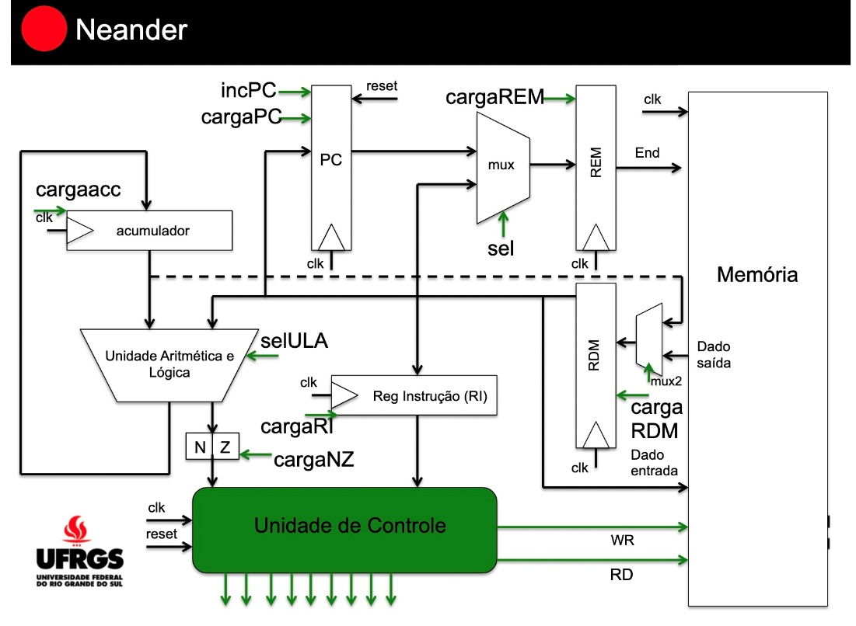

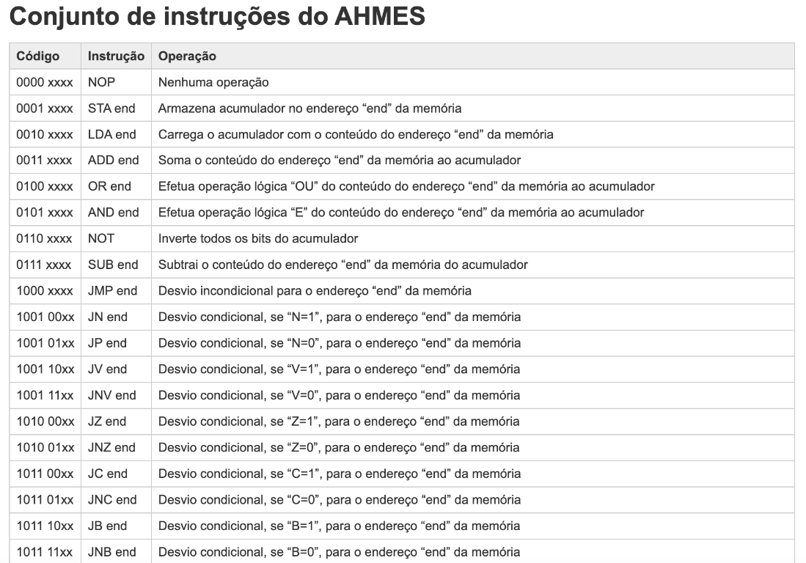

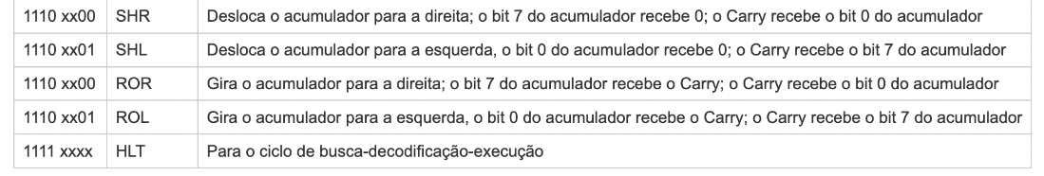

**AULA 1 (24/1/2023)**

Descrever o DATAPATH do processador RAMSES em VHDL em uma entidade apenas chamada de datapath_ramses.

1. ***Cole aqui o código completo em VHDL do datapath***

library IEEE;

use IEEE.STD_LOGIC_1164.ALL;

use IEEE.STD_LOGIC_UNSIGNED.ALL;

use IEEE.NUMERIC_STD.ALL;

entity datapath_ahmes is

Port

(

CLOCK : in STD_LOGIC;

RESET : in STD_LOGIC := '0';

DOUT : out STD_LOGIC_VECTOR (7 downto 0);

N : out STD_LOGIC;

Z : out STD_LOGIC;

V : out STD_LOGIC;

C : out STD_LOGIC;

B : out STD_LOGIC

);

end datapath_ahmes;

architecture Behavioral of datapath_ahmes is

-- PC

signal reg_PC: std_logic_vector (7 downto 0);

signal load_PC: std_logic := '0';

signal inc_PC: std_logic := '0';

-- AC

signal reg_AC: std_logic_vector (7 downto 0);

signal load_AC: std_logic := '0';

-- ULA

signal ULA_X: std_logic_vector (7 downto 0); -- é o reg_AC

signal ULA_Y: std_logic_vector (7 downto 0); -- é o reg_RDM;

signal ULA_out: std_logic_vector (7 downto 0);

signal sel_ULA: std_logic_vector (3 downto 0);

-- FLAGS

signal reg_N: std_logic := '0';

signal reg_Z: std_logic := '0';

signal reg_V: std_logic := '0';

signal reg_C: std_logic := '0';

signal reg_B: std_logic := '0';

signal load_flag: std_logic := '0';

-- MUX_REM

signal MUX_REM_out: std_logic_vector (7 downto 0);

signal sel_REM_MUX: std_logic :='0';

-- REM

signal reg_REM: std_logic_vector (7 downto 0);

signal load_REM: std_logic := '0';

-- MUX_RDM

signal MUX_RDM_out: std_logic_vector (7 downto 0);

signal sel_RDM_MUX: std_logic :='0';

-- RDM

signal reg_RDM: std_logic_vector (7 downto 0);

signal load_RDM: std_logic := '0';

-- RI

signal reg_RI: std_logic_vector (7 downto 0);

signal load_RI: std_logic := '0';

-- DECOD

signal reg_DECOD: std_logic_vector(7 downto 0);

signal DECOD_out: std_logic_vector(23 downto 0);

signal DECOD_sel: std_logic_vector(4 downto 0);

-- MEM

signal reg_mem: std_logic_vector (7 downto 0);

signal read_mem: std_logic := '0';

signal write_mem: std_logic := '0';

-- variables

component memoria

PORT

(

clka : IN STD_LOGIC;

wea : IN STD_LOGIC_VECTOR(0 DOWNTO 0);

addra : IN STD_LOGIC_VECTOR(7 DOWNTO 0);

dina : IN STD_LOGIC_VECTOR(7 DOWNTO 0);

douta : OUT STD_LOGIC_VECTOR(7 DOWNTO 0)

);

end component;

begin -- inicio behavioral

-- MEM

--MEM: memoria

-- PORT MAP

-- (

-- clka => CLOCK,

-- wea => write_mem,

-- addra => reg_mem,

-- dina => reg_AC,

-- douta => reg_mem

-- );

process (CLOCK, RESET) -- PC

begin

if (RESET ='1') then

reg_PC <= "00000000";

elsif (rising_edge(CLOCK)) then -- na subida do clock

if (load_PC='1') then

reg_PC<= reg_RDM;

elsif(inc_PC='1') then

reg_PC <= std_logic_vector(unsigned(reg_PC) + 1);

else

reg_PC <= reg_PC;

end if;

end if;

end process;

process (CLOCK, RESET) -- AC

begin

if (RESET='1') then

reg_AC <= "00000000";

elsif (rising_edge(CLOCK)) then -- na subida do clock

if (load_AC='1') then

reg_AC <= ULA_out;

else

reg_AC <= reg_AC;

end if;

end if;

end process;

-- ULA

ULA_X <= reg_AC; -- recupera valor X do acumulador

ULA_Y <= reg_MEM; -- recupera valor Y de uma posicao da memória

process(sel_ULA, ULA_X, ULA_Y, reg_C)

variable C_temp: std_logic := '0';

begin

case sel_ULA is

when "0000" =>

if((ULA_X + ULA_Y) > 127) then

reg_V <= '1';

else

reg_V <= '0';

end if;

reg_B <= '0';

reg_C <= '0';

ULA_out <= (ULA_X + ULA_Y); -- operacao ADD

when "0001" =>

reg_V <= '0';

reg_B <= '0';

reg_C <= '0';

ULA_out <= (ULA_X OR ULA_Y); -- operacao OR

when "0010" =>

reg_V <= '0';

reg_B <= '0';

reg_C <= '0';

ULA_out <= (ULA_X AND ULA_Y); -- operacao AND

when "0011" =>

reg_V <= '0';

reg_B <= '0';

reg_C <= '0';

ULA_out <= (NOT ULA_X); -- operacao NOT

when "0100" =>

if((ULA_X - ULA_Y) < 0) then

reg_C <= '1';

reg_B <= '1';

else

reg_V <= '0';

reg_B <= '0';

reg_C <= '0';

end if;

reg_V <= '0';

ULA_out <= (ULA_X - ULA_Y); -- operacao SUB

when "0101" => -- operacao SHR

reg_V <= '0';

reg_B <= '0';

reg_C <= ULA_X(0);

ULA_out(7) <= '0';

ULA_OUT(6) <= ULA_X(7);

ULA_OUT(5) <= ULA_X(6);

ULA_OUT(4) <= ULA_X(5);

ULA_OUT(3) <= ULA_X(4);

ULA_OUT(2) <= ULA_X(3);

ULA_OUT(1) <= ULA_X(2);

ULA_OUT(0) <= ULA_X(1);

when "0110" => -- operacao SHL

reg_V <= '0';

reg_B <= '0';

reg_C <= ULA_X(7);

ULA_out <= (ULA_X + ULA_X);

when "0111" => -- operacao ROR

reg_V <= '0';

reg_B <= '0';

C_temp := ULA_X(0);

ULA_out(7) <= reg_C;

ULA_OUT(6) <= ULA_X(7);

ULA_OUT(5) <= ULA_X(6);

ULA_OUT(4) <= ULA_X(5);

ULA_OUT(3) <= ULA_X(4);

ULA_OUT(2) <= ULA_X(3);

ULA_OUT(1) <= ULA_X(2);

ULA_OUT(0) <= ULA_X(1);

reg_C <= C_temp;

when "1000" => -- operacao ROL

reg_V <= '0';

reg_B <= '0';

C_temp := ULA_X(7);

ULA_out <= (ULA_X + ULA_X);

ULA_out(0) <= reg_C;

reg_C <= C_temp;

when others => ULA_out <= "XXXXXXXX";

end case;

end process;

process (CLOCK, RESET) -- FLAGS

begin

if (RESET = '1') then

reg_N <= '0';

reg_Z <= '0';

reg_V <= '0';

reg_B <= '0';

--reg_C <= '0';

elsif(rising_edge(CLOCK)) then -- na subida do clock

if reg_AC = "00000000" then

reg_Z <= '1';

else

reg_Z <= '0';

end if;

reg_N <= reg_AC(7); -- msb do registrador AC

end if;

end process;

process (sel_REM_MUX, reg_PC, MUX_RDM_out) -- MUX_REM

begin

if (sel_REM_MUX = '0') then

MUX_REM_out <= reg_PC;

else

MUX_REM_out <= MUX_RDM_out;

end if;

end process;

process(CLOCK, RESET) -- REM

begin

if (RESET='1') then

reg_REM <= "00000000";

elsif (rising_edge(CLOCK)) then -- na subida do clock

if (load_REM ='1') then

reg_REM <= MUX_REM_out;

else

reg_REM <= reg_REM;

end if;

end if;

end process;

process (sel_RDM_MUX, reg_mem, reg_AC) -- MUX_RDM

begin

if(sel_REM_MUX = '0') then

MUX_RDM_out <= reg_MEM;

else

MUX_RDM_out <= reg_AC;

end if;

end process;

process (CLOCK, RESET) -- RDM

begin

if (RESET = '1') then

reg_RDM <= "00000000";

elsif (rising_edge(CLOCK)) then

if (load_RDM = '1') then

reg_RDM <= reg_AC;

else

reg_RDM <= MUX_RDM_out;

end if;

end if;

end process;

process (CLOCK, RESET) -- RI

begin

if (RESET='1') then

reg_RI <= "00000000";

elsif (rising_edge(CLOCK)) then

if (load_RI = '1') then

reg_RI <= reg_RDM;

else

reg_RI <= reg_RI;

end if;

end if;

end process;

-- DECOD

reg_DECOD <= reg_RI;

process(reg_decod)

begin

DECOD_out <= "000000000000000000000000";

case reg_DECOD is

when "00000000" => DECOD_out(0) <= '1'; -- 00 NOP

when "00010000" => DECOD_out(1) <= '1'; -- 16 STA

when "00100000" => DECOD_out(2) <= '1'; -- 32 LDA

when "00110000" => DECOD_out(3) <= '1'; -- 48 ADD

when "01000000" => DECOD_out(4) <= '1'; -- 64 OR

when "01010000" => DECOD_out(5) <= '1'; -- 80 AND

when "01100000" => DECOD_out(6) <= '1'; -- 96 NOT

when "01110000" => DECOD_out(7) <= '1'; -- 112 SUB

when "10000000" => DECOD_out(8) <= '1'; -- 128 JMP

when "10010000" => DECOD_out(9) <= '1'; -- 144 JN

when "10010100" => DECOD_out(10) <= '1'; -- 148 JP

when "10011000" => DECOD_out(11) <= '1'; -- 152 JV

when "10011100" => DECOD_out(12) <= '1'; -- 156 JNV

when "10100000" => DECOD_out(13) <= '1'; -- 160 JZ

when "10100100" => DECOD_out(14) <= '1'; -- 164 JNZ

when "10110000" => DECOD_out(15) <= '1'; -- 176 JC

when "10110100" => DECOD_out(16) <= '1'; -- 180 JNC

when "10111000" => DECOD_out(17) <= '1'; -- 184 JB

when "10111100" => DECOD_out(18) <= '1'; -- 188 JNB

when "11100000" => DECOD_out(19) <= '1'; -- 224 SHR

when "11100001" => DECOD_out(20) <= '1'; -- 225 SHL

when "11100010" => DECOD_out(21) <= '1'; -- 226 ROR

when "11100011" => DECOD_out(22) <= '1'; -- 227 ROL

when "11110000" => DECOD_out(23) <= '1'; -- 240 HLT

when others => DECOD_out <= "000000000000000000000000";

end case;

end process;

end Behavioral;

1. Qual componente FPGA escolheste para a síntese? Artix 7 – xc7a100t-3csg324
2. Quantos registradores tem o datapath do AHMES? 13
3. Quantas operações diferentes tem a ULA? 9
4. A área do DATAPTH em # LUTs: ___________ e #ffps: ___________________

**\*\*\*ENTREGAR DIA da PARTE 1 29/1/2022**** Editando esse DOC e submetendo no MS-TEAMS**